# Project Planning Phase

**Project Planning Template (Product Backlog, Sprint Planning, Stories, Story points)**

|  |  |  |  |  |  |  |
| --- | --- | --- | --- | --- | --- | --- |
| Sprint | Functional  Requirement  (Epic) | User  Story  Number | User Story / Task  Description | Story  Points | Priority | Team  Members |
| Sprint-1 | Data  Collection and integration | USN-1 | Gather relevant environmental data, including temperature, humidity, soil moisture and light levels. | 7 | High | Mohan |
|  | Data preparation | USN-2 | Cleans the collected data for analysis. | 8 | High | Mohan, Mukhesh |
| Sprint-2 | Data Analysis and modelling | USN-3 | Utilize Power BI.s analytical tools to explore relationships between environmental factors and plants growth stages | 5 | Low | John prabhakar, Mohan |
|  | Visualization  Development | USN-4 | Create interactive visualization for key metrics | 8 | Medium | John Prabhakar,Mohan |
|  | Dashboard  Design | USN-5 | Design user-friendly interfaces that allow stakeholders to easily access and interpret data. | 8 | High | Mohan,Mukhesh |

|  |  |
| --- | --- |
| Date | 15 February 2025 |
| Team ID | PNT2025TMID06968 |
| Project Name | Prediction plant growth stages with environment and management data using power BI |
| Maximum Marks | 5 Marks |

# Product Backlog, Sprint Schedule, and Estimation (4 Marks)

Use the below template to create product backlog and sprint schedule

|  |  |  |  |  |  |  |
| --- | --- | --- | --- | --- | --- | --- |
| **Sprint** | **Functional**  **Requirement (Epic)** | **User Story**  Number | **User Story / Task** | **Story Points** | **Priority** | **Team**  **Members** |
| Sprint-2 | Data Analysis | USN-3 | Utilize Power BI’s analytical tools to explore relationships between environmental factors and plant growth stages. | 5 | Low | J.Mohan |
|  | Visualization  Development | USN-4 | Create interactive visualization for key metrics. | 6 | Medium | K.Mukhesh |
|  | Dashboard Design | USN-5 | Design user-friendly interfaces that allows stakeholders to easily access and interpret data. | 8 | High | J.Mohan |

# Project Tracker, Velocity & Burndown Chart: (4 Marks)

|  |  |  |  |  |  |  |
| --- | --- | --- | --- | --- | --- | --- |
| Sprint | Total Story  Points | Duration  (Days) | Start Date | End Date (Planned) | Story Points Completed (Planned) | Release Date  (Actual) |
| Sprint1 | 20 | 6 | 2 feb 2025 | 7 feb 2025 | 20 | 29 Oct 2022 |
| Sprint1 | 20 | 6 | 7 feb 2025 | 12 feb 2025 | 20 | 05 Nov 2022 |
| Sprint2 | 20 | 6 | 12 feb 2025 | 17 feb 2025 | TBD | TBD |
| Sprint2 | 20 | 6 | 17 feb 2025 | 22 feb 2025 | TBD | TBD |

**Velocity:**

Imagine we have a 10-day sprint duration, and the velocity of the team is 20 (points per sprint). Let’s calculate the team’s average velocity (AV) per iteration unit (story points per day)

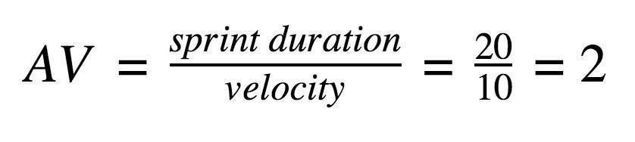

**Burndown Chart:**

A burndown chart illustrates:

* X-axis: Sprint duration (time in days).
* Y-axis: Remaining story points.
* It starts with 20 story points at day 0 and decreases daily based on completed points.